

**NAMA : TITO FEBRI ANGGARA**

**NIM : 210511126**

**KELAS : R3(C)**

Overload 1

class jajan:

def __init__(self, fare):

self.fare = fare

def __add__(self, other):

return self.fare+other.fare

eskelapa = jajan(10)

baso = jajan(13)

total = eskelapa+baso

print(f'\nHarga Total: {str(total)}k\n')

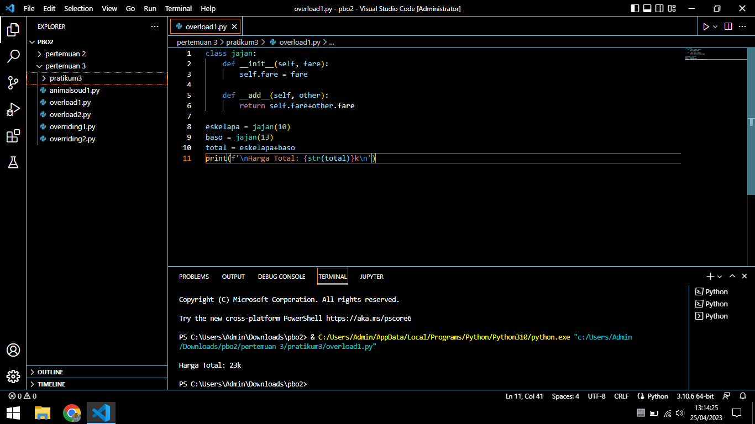

Overload 2

class vektor:

def __init__(self,x,y):

self.x = x

self.y = y

def __str__(self):

return f'{self.x}i{self.y:+}j'

def __abs__(self):

return (self.x ** 2 + self.y ** 2) ** 0.5

vektor1 = vektor(9,12)

print('\nVektor\t\t: '+str(vektor1))

print('Panjang Vektor\t: ',abs(vektor1),'\n')

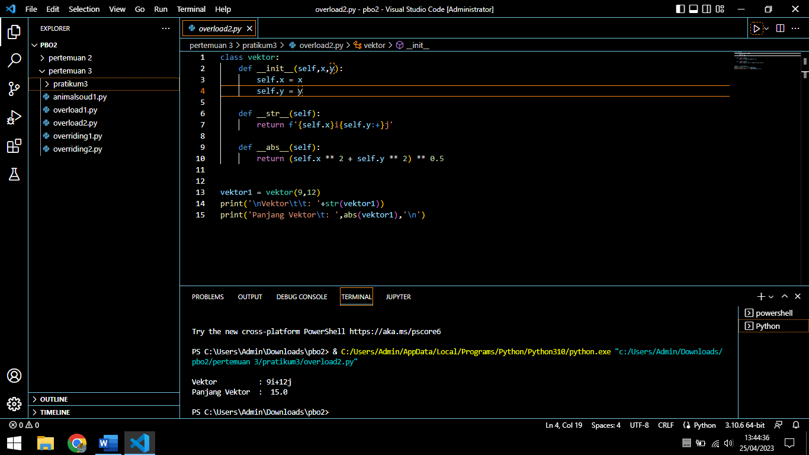

Overidding 1

#TITO FEBRI ANGGARA

#210511126

#TI21C

class membership:

diskon = 0.1

def __init__(self,nama,kode,treat,harga):

self.nama = nama

self.kode = kode

self.treat = treat

self.harga = harga

def display(self):

print('\n\tDiskon Membership\t\n','='*30)

print('Nama\t\t: ',self.nama)

print('Kode Member\t: ',self.kode)

print('Treatment\t: ',self.treat)

print(f'Bayar\t\t: {self.harga}\n')

def bayar(self):

diskon = (self.harga)*self.diskon

self.harga = self.harga-diskon

return self.harga

class platinum(membership):

diskon = 0.2

def __init__(self,nama,kode,treat,harga):

super().__init__(nama,kode,treat,harga)

def bayar(self):

diskon = (self.harga)*self.diskon

self.harga = self.harga-diskon

return self.harga

class gold(membership):

diskon = 0.45

def __init__(self,nama,kode,treat,harga):

super().__init__(nama,kode,treat,harga)

def bayar(self):

diskon = (self.harga)*self.diskon

self.harga = self.harga-diskon

return self.harga

member1 = membership('Qiski','D230329','Spa',300000)

member1.bayar()

member1.display()

member2 = gold('sasa','B210112','Facial Treatment',750000)

member2.bayar()

member2.display()

member3 = platinum('lagter','K220101','Facial Treatment',750000)

member3.bayar()

member3.display()

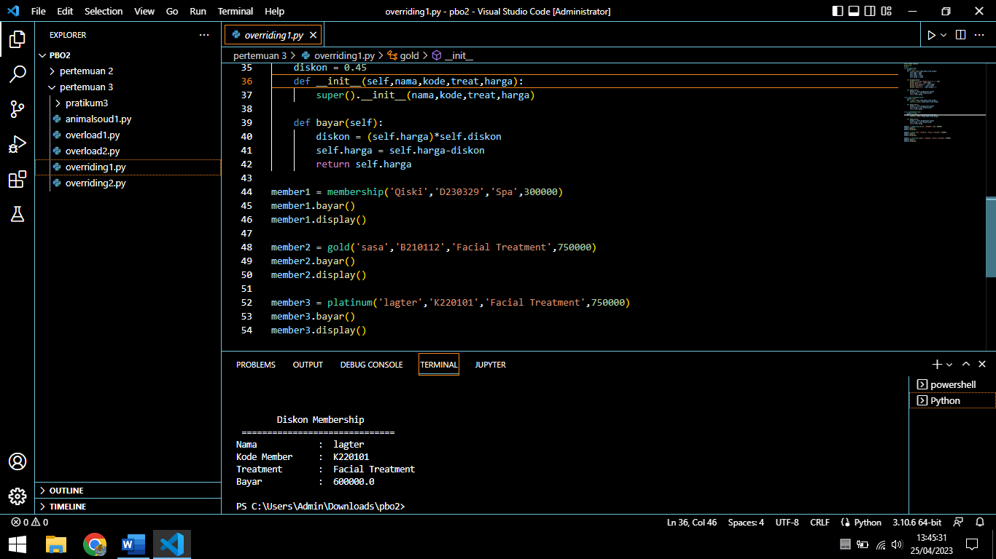

Overidding 2

class Hero:

def help(self):

print("Hero akan datang")

class Superman(Hero):

def help(self):

print("Suparman datang menolong")

class Batman(Hero):

def help(self):

print("Batman segera datang menghampirimu")

class anjas(Superman):

def help(self):

print("Anjas akan menolongmu")

class Jono(Superman):

def help(self):

print("Jono sang pahlawan kesiangan akan menghampirimu")

def hero_help(hero):

hero.help()

hero = Hero()

parman = Superman()

batman = Batman()

orang1 = anjas()

orang2 = Jono()

hero_help(hero)

hero_help(parman)

hero_help(batman)

hero_help(orang1)

hero_help(orang2)

